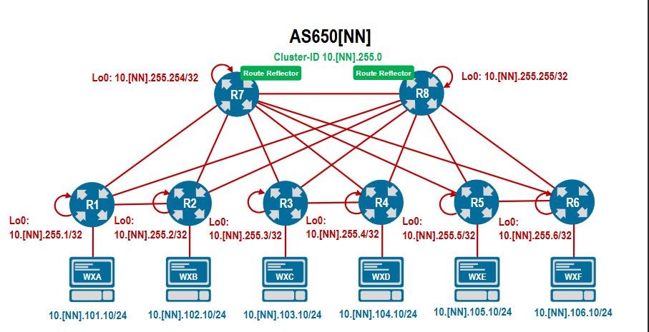
r7

router bgp 65046
router-id 10.46.255.255
bgp log-neighbor-changes
neighbor 10.46.255.254 remote-as 65046
neighbor 10.46.255.254 next-hop-self
neighbor 10.46.255.254 update-source Loopback0
neighbor 10.46.255.254 password lab123!

router-id 10.46.255.254

r7 ja r8
router bgp 65046
route-reflector preserve-attributes
neighbor 10.46.255.254 remote-as 65046
neighbor 10.46.255.254 next-hop-self
neighbor 10.46.255.254 update-source Loopback0
neighbor 10.46.255.254 password lab123!
neighbor RRCLIENT peer group
neighbor RRCLIENT remote-as 65046
neighbor RRCLIENT next-hop-self
neighbor RRCLIENT update-source Loopback0
neighbor RRCLIENT password lab123!
neighbor 10.46.255.1 peer group RRCLIENT
neighbor 10.46.255.2 peer group RRCLIENT
neighbor 10.46.255.3 peer group RRCLIENT
neighbor 10.46.255.4 peer group RRCLIENT
neighbor 10.46.255.5 peer group RRCLIENT
neighbor 10.46.255.6 peer group RRCLIENT

r1-r6
router bgp 65046
router-id 10.46.255.1
bgp log-neighbor-changes
neighbor RR update-source loopback0
neighbor RR next-hop-self
neighbor RR password lab123!
neighbor 10.46.255.254 peer group RR
neighbor 10.46.255.255 peer group RR
redistribute connected

R7 ja r8
router bgp 65046
neighbor RRCLIENT route-reflector-client

cluster id
r7
router pgb 65046
bgp cluster-id 10.46.255.0

